**Ad-Supported Revenue Distribution from 2019 - 2024 (in Million EUR):**

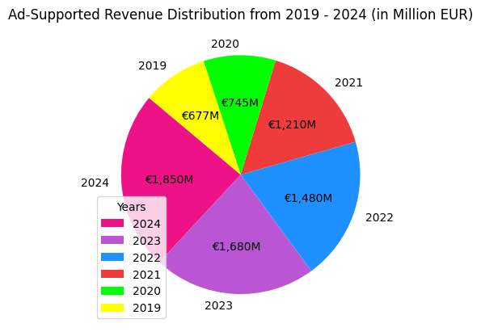

Detailed explanation:

The pie chart displays the growth of **Spotify’s ad-supported revenue** from **2019** to **2024** in **million** **euros**. In **2019**, generated revenue was **€677M**, rising to **€745M** in **2020**. A significant jump occurred in **2021**, reaching **€1,210M**. This upward trend continued with **€1,480M** in **2022**, **€1,680M** in **2023**, and peaked at **€1,850M** in **2024**. The color-coded sections help differentiate yearly figures, by tracking the increasing ad-generated income easier.

Key statement:

The steady rise in ad-supported revenue indicates Spotify’s success in growing its free-tier user base and improving ad placement strategies. As the platform attracts more advertisers, revenue from this segment continues to expand.